I.T. Program
ANOKA TECHNICAL COLLEGE
Christopher Beaudoin
Fall 2024 Web Development Technologies
Table of Contents
KEY: 2
MAIN ELEMENTS OUTLINE: 2
HIERARCHY CHART STORYBOARD: 2
MEASUREMENT OF SUCCESS: 2
TARGET AUDIENCE ANALYSIS 2
SITE STANDARDS: 2
TEMPLATES: 2
NAMING CONVENTIONS: 2
INDUSTRY STANDARD: 2
DEVELOPMENT STANDARD: 2
GRAPHICS SPECIFICATIONS: 2
TEST PLAN: 2
MAINTENANCE PLAN: 2
EXTERNAL CSS: 2

KEY:

MAIN ELEMENTS OUTLINE:

Home: Welcome page – This will be an introduction to the History of the Boeing 737 Aircraft.
- Specifications: Information will be provided on all specifications of the Boeing 737 Aircraft. For examples: Length, Weight, Take-off speed, Engines Specifications, etc.
- Variants: Information of the different variants of the Boeing 737 Aircraft and when they were first entered into service.
- Operating Airlines: Information on what current airlines in the world operate the Boeing 737 Aircraft and their variants.
- Boeing 737 Flaws/Disasters: Information on all flaws that have been recorded since the 1st Boeing 737 entered service. Information on certain air disasters that have occurred during the Boeing 737’s history will be provided.
- Boeing 737 Comment Page: This will a page where users can send me a message on any comments or concerns they have with the website.
HIERARCHY CHART STORYBOARD:

MEASUREMENT OF SUCCESS FOR THE HISTORY OF THE BOEING 737 AIRCRAFT:

What will be measured: Customer Satisfaction.

Measurement of Success: A survey will be conducted with a star-based questions regarding the users experience on the website. A scale of 1-5 stars will be used and a 90% of the responses must be 4 stars or higher for this website to be considered a success.

TARGET AUDIENCE ANALYSIS:
Gender: This website is targeted towards and accessible to all genders.
Age: This content targets users 13 and up.
Education Level: 8th grade in Grade School or higher.
Reading and Vocabulary Level: 8th grade reading level or higher. All aviation specific terms will be defined.
Technical Aptitude: All users must be able to:
- Access a Desktop and or Laptop.
- Open a browser.
- Navigate to the website.
- Use a mouse and keyboard.
Connection Speed: This website is designed to be accessible at all connection speeds.
Browsers: Designed to be displayed correctly on the most recent versions (09/24) of – i.e. Firefox, Chrome, Edge, Internet Explorer.
Operating systems: Built to be accessible to users of all current operating systems.
Resolutions: Built to be viewed successfully at all resolutions.

SITE STANDARDS:

TEMPLATES:

Graphic Image & Page Header

Navigation Menu & Page Links
Site Content

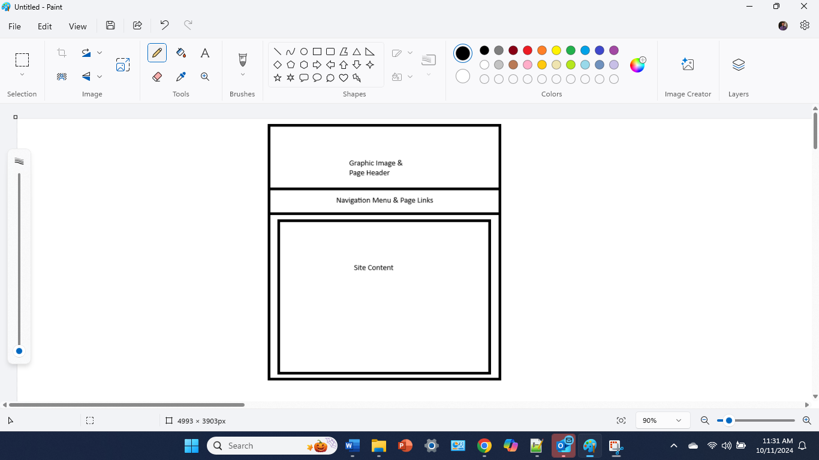

NAMING CONVENTIONS:

INDUSTRY STANDARD: This site will be developed following the industry standard of the WCAG guideline: The current file naming standard (as of April 2019) for section 508 compliance is as follows:

Don’t start or end your filename with a space, period, hyphen, or underline.

Filenames cannot exceed 255 characters in length.

Always use lowercase.

Don’t use special characters, spaces, and underscores; use a hyphen instead.

DEVELOPMENT STANDARD: Pages for this “History of the Boeing 737 Aircraft” Website site will be named using the links names without any space or special characters (other than the hyphen), and names cannot exceed 255 characters. You must follow the WCAG guidelines. Please see below for examples:

index.html

737-specs.html

737-variants.html

737-airlines.html

737-flawsdisasters.html

737-comments.html

GRAPHICS SPECIFICATIONS:

Approval process for adding new pages and/or graphics:
- All requests for the addition of new pages or changes requests for existing pages must be submitted via email to the Webmaster.
- All requests for graphic changes must be submitted via email to the Webmaster.
- Every 1st Friday of the month the Webmaster will review all submitted change requests emailed. All approved changes will be completed within 1 business day unless otherwise noted.
- All new pages must use all existing Templates used in the site.
- Graphics must comply with the Graphics standards identified in the Site Standards document.

Legalities:
- Copyright Materials:
- The use of Copyright materials is NOT permitted on this site.
- Personal Materials:
- The use of personal materials is NOT permitted on this site.
File size Requirement:
- The Dimensions of all images must be small than the container in which it will display.
- Be sure to check the margins, padding, and borders assigned to the containers.
- Use the appropriate graphics editing tool to resize the graphics.
- There is No restrictions on the File Size as the connection speeds of the users of this site will generally be a high-speed broadband internet connection (20MB or higher).

TEST PLAN:

- Browsers: The most recent versions of:
- Chrome
- Firefox
- Edge
- Safari
- Internet Explorer
- Connection Speeds:
- Download speed of 124 MBPS
- Location: Home Network.
- Resolutions:
- 1366 x 768 (Recommended)
- 1280 x 720 (Native)
- Operating Systems:
- Windows 11 Home
- Validation:
- All pages will be validated as they are completed and when any changes are made.
- Any embedded CSS rules and every HTML will be validated by the W3C.
- Any external CSS pages will be validated using the W3C CSS validator.
- Upon completion of the entire website, it will be validated for both the HTML and CSS before publication. Any and all warning must be corrected before publication.

MAINTENANCE PLAN:

Schedule for Updating Site: Any new information related to the Boing 737 Aircraft should be updated to ensure that visitors to the site are seeing the current/relevant information for the Boeing 737 Aircraft. This will be done monthly.
- Every 1st Friday of the month before 5:00 PM the 737-index page will be updated to reflect the new information about the Boeing 737 Aircraft.
- Every page related to the Boeing 737 Aircraft must also be updated to reflect the changes.
Approval Process for adding new pages and/or graphics:
- All requests for the addition of new pages or changes requests for existing pages must be submitted via email to the Webmaster.
- All requests for graphic changes must be submitted via email to the Webmaster.
- Every 1st Friday of the month the Webmaster will review all submitted change requests emailed. All approved changes will be completed within 1 business day unless otherwise noted.
- All new pages must use existing Templates and CSS code used in the site.
Test schedule for site functionality for links, graphics and forms:
- Every page must be tested to ensure that all links, graphics and forms are working and/or displaying correctly.
- Google Analytics will be used for testing functionality of the site links, graphics, and forms.
- Analytics reports will be run every Friday morning at 9:00 AM.
- All issues/errors will be addressed and corrected by the end of the day on Friday.

Video Link to Presentation:

https://share.vidyard.com/watch/WR8LJrqvLASUS6kou4hFaW?

